**Types of Security Testing**

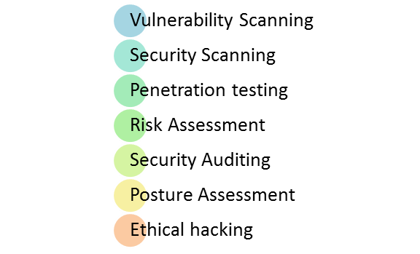

* **Vulnerability Scanning**: This is done through automated software to scan a system against known vulnerability signatures.
* **Security Scanning:** It involves identifying network and system weaknesses, and later provides solutions for reducing these risks. This scanning can be performed for both Manual and Automated scanning.
* **Penetration testing**: This kind of testing simulates an attack from a malicious hacker. This testing involves analysis of a particular system to check for potential vulnerabilities to an external hacking attempt.
* **Risk Assessment:** This testing involves analysis of security risks observed in the organization. Risks are classified as Low, Medium and High. This testing recommends controls and measures to reduce the risk.
* **Security Auditing:** This is an internal inspection of Applications and Operating systems for security flaws. An audit can also be done via line by line inspection of code
* **Ethical hacking:** It’s hacking an Organization Software systems. Unlike malicious hackers, who steal for their own gains, the intent is to expose security flaws in the system.
* **Posture Assessment:** This combines Security scanning,[Ethical Hacking](https://www.guru99.com/ethical-hacking-tutorials.html)and Risk Assessments to show an overall security posture of an organization.